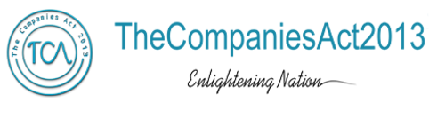
ANNEXURE IX
Statement of Assets and Liabilities for Companies (Other than Banks)

Standalone / Consolidated  Statement of Assets and Liabilities  Particulars | As at (Current half year end / Year end (dd/mm/yyyy) | As at (Previous year  end) (dd/mm/yyyy)
- EQUITY AND LIABILITIES
- Shareholders’ funds
- Share capital
- Reserves and surplus
- Money received against share warrants
Sub-total - Shareholders' funds
- Share application money pending allotment
- Minority interest *
4. Non-current liabilities
- Long-term borrowings
- Deferred tax liabilities (net)
- Other long-term liabilities
- Long-term provisions
Sub-total - Non-current liabilities
5. Current liabilities
- Short-term borrowings
- Trade payables
- Other current liabilities
- Short-term provisions

Sub-total - Current liabilities
TOTAL - EQUITY AND LIABILITIES
- ASSETS
- Non-current assets
- Fixed assets
- Goodwill on consolidation
- Non-current investments
- Deferred tax assets (net)
- Long-term loans and advances
- Other non-current assets
Sub-total - Non-current assets
- Current assets
- Current investments
- Inventories
- Trade receivables
- Cash and cash equivalents
- Short-term loans and advances
- Other current assets
Sub-total - Current assets
Total -Assets

*Applicable in the case of consolidated statement of assets and Liabilities

